VIEWS

**Aim:**

* Create table student with attributes id, name and department.
* Display
* Create view and select
* Insert values
* Create view with check option
* Insert values and alter table.
* Create table student with attributes id, name and department.

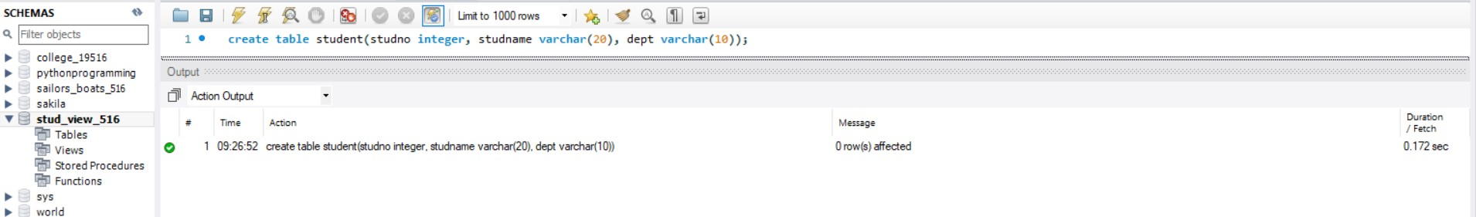

* Display

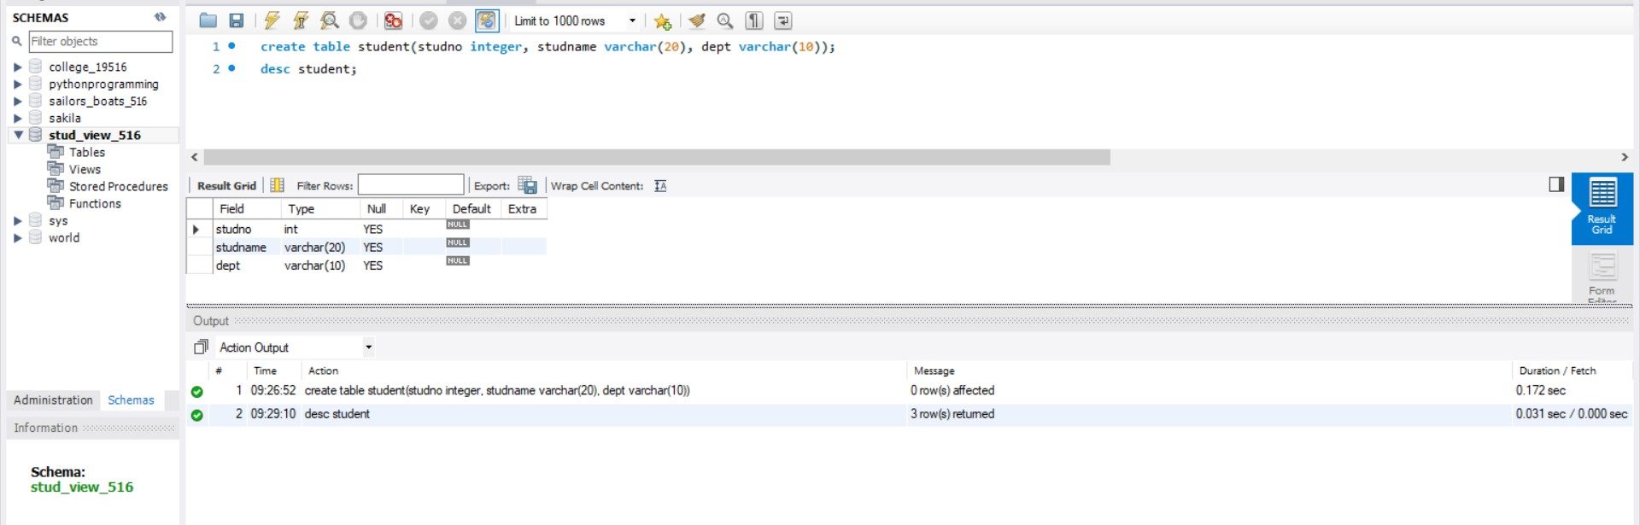

* Create view and select

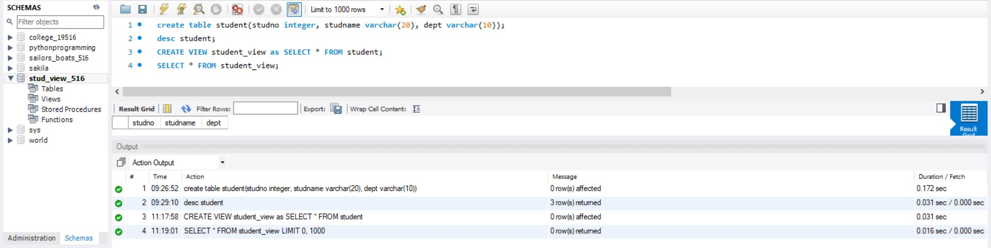



* Insert values

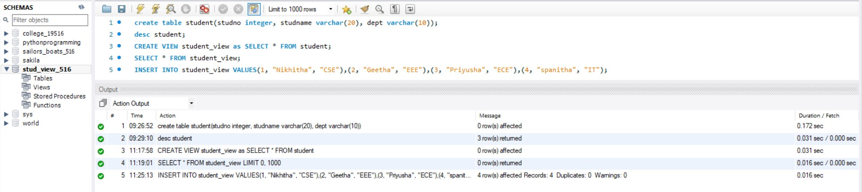



* Create view with check option

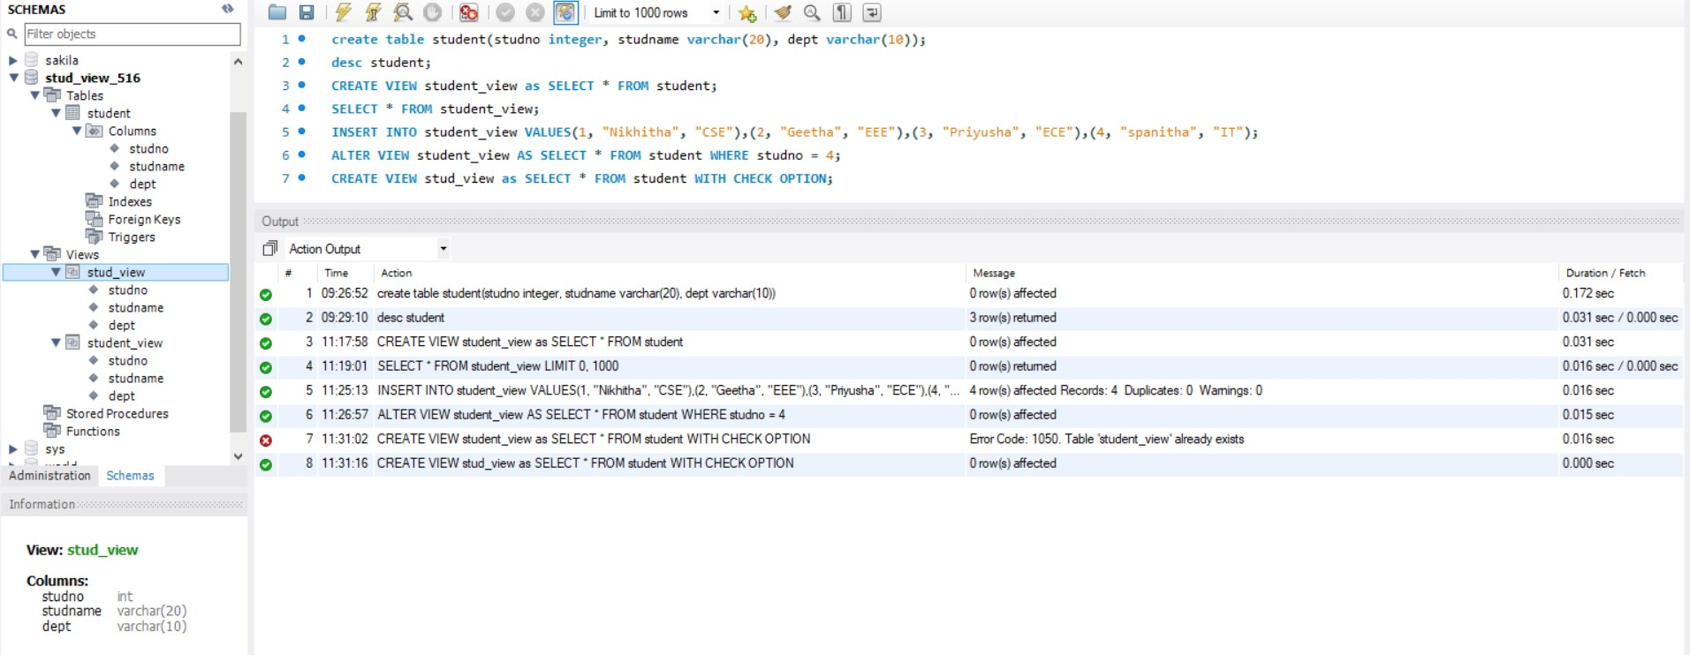

* Insert values and alter table.

